Hart County Bulldog Band Stands Cheers 2017
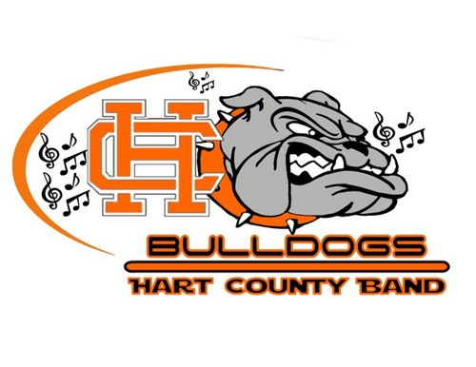
NEW
Title and Link to recording
- Krypton Fanfare (UGA)
https://www.youtube.com/watch?v=jYcZpNrYWPs
- Hail to Georgia (UGA)
https://www.youtube.com/watch?v=DMvai5igLtk
- Bulldog Bite (UGA)
https://www.youtube.com/watch?v=oLUsWoJ5Myc

- Thumb Cheer (Auburn)
https://www.youtube.com/watch?v=4hy0YG4ChjQ
- Auburn First Down (Auburn) **NOT OUR FIRST DOWN CHEER**STILL GLORY TAG**
https://www.youtube.com/watch?v=g9g2GSXhHHE
- Tiger Walk (Auburn)
https://www.youtube.com/watch?v=p_wF8SXpOJo

- Requiem (Auburn)
https://www.youtube.com/watch?v=CMROoym3rPY
- O Fortuna (Auburn)
https://www.youtube.com/watch?v=EsMBL5lUhUA
- Gladiator Cheer (Auburn)
https://www.youtube.com/watch?v=0YXZBTQod-k

- Night On Bald Mountain Defense Shortie **ONLY ABOUT THE FIRST 32secs.**
https://www.youtube.com/watch?v=3wwFE9rLLVg
- Boogie Shoes
** I DON’T HAVE A RECORDING, BUT I WILLTRY TO GET ONE TO YOU**
- Hey Baby
** I DON’T HAVE A RECORDING, BUT I WILLTRY TO GET ONE TO YOU**

We are also saying goodbye to some of our tunes…
- Lets Go Bulldogs
- Riff (Only the ending of this cheer will be played in the stands)
- Low Rider
- Cupid Shuffle
- Jump On It

